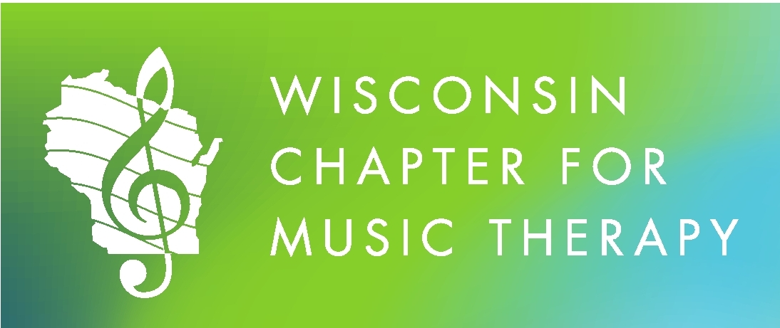

Proudly Presents:

Influence of Music on Human Behavior 2.0
Presented by Leslie Henry, MM, MT-BC
Director of Music Therapy and Assistant Professor
Alverno College

And WCMT Business Meeting
Sponsored by WCMT
In cooperation with GLR-AMTA

Saturday, September 30, 2017
7:30-4:00 ~ 8 hour CMTE
Alverno College
3400 S. 43rd Street ~ Milwaukee, WI
Alphonsa Hall 258 (Choir Room)

Early Bird Registration Deadline is Wednesday, September 13, 2017

Influence of Music on Human Behavior 2.0 is approved by the Certification Board for Music Therapists (CBMT) for 8 Continuing Music Therapy Education credits. The Great Lakes Region of the American Music Therapy Association, #P-021, maintains responsibility for program quality and adherence to CBMT policies and criteria.

Course Description:
Do you ever get tongue-tied or have difficulty in just the right thing to say when describing methods of music therapy or why music can hasten healing?

This CMTE will explore our cultural, societal, psychological connections to music and why neurologically we benefit from music engagement. The session provide opportunities to learn terms in cognitive and learning psychology models like bottom-up processing, top-down processing, Hebbian theory, feedback and feed-forward models and explore the value of autobiographical music, creativity and improvisation in the work we do. It will be intentionally designed for application to all populations and involve both didactic and experiential learning for a variety of learners.

Learner Objectives:
- Identify ways to provide music therapy experiences to meet cognitive and neurological function.
- Describe ways music therapy experiences can influence attention, executive function, memory, sensorimotor, sensory integration, sensory orientation, and sensory perception.
- Recognize and describe how neurological models inform music therapy treatment approaches and clinical practice.

Presenter:
Leslie Henry, MM, MT-BC has worked in a variety of healthcare and community based settings with experience from birth to senescence in for-profit, non-profit, and government positions. She is the Director and Assistant Professor of Music Therapy at Alverno College.

She studied music therapy at UW Milwaukee and Alverno College and Master of Music with an emphasis in Music Therapy from Colorado State University. She holds a designation of fellow with the Robert F. Unkefer Academy of Neurologic Music Therapists.

Leslie has trained interns and practicum students in geriatric, developmental disabilities, and behavioral health clinical placements. Professionally she has served with state, regional, and national leadership. Currently, Leslie is Co-Chair to the Professional Advocacy Committee of the American Music Therapy Association, Inc. and a member of the American Music Therapy Association, Inc. Music and Memory ℠ workgroup.
Schedule:
7:30-8:00 Registration and continental breakfast
8:00-11:45 CMTE
11:45-12:30 Lunch
12:30 WCMT Meeting
1:30-4:00 CMTE
Food & Beverage:
A light breakfast will be provided, in addition to an afternoon snack. Lunch is on your own. The Commons will be open for lunch. You may also bring your own bag lunch. There are also a variety of fast food restaurants located on and around South 27th Street.

Cancellation/Refund Policy:
100% of the registration fee will be refunded if you cancel up to 4 days before the event. After that date, a 75% refund will be given.

Influence of Music on Human Behavior 2.0
Registration

On-line Registration & PayPal Payment Available at:
www.musictherapywisconsin.org

***Early Bird Registration Deadline is Wednesday, September 13, 2017 ***

Mail Registration – Please complete the form below:
(The Deadline for mail registration is 9/23/17)

Name: _______________________________________________________________________________________________

Street Address: ____________________________________________________________________________________

City, State, Zip: _____________________________________________________________________________________

Email: ___________________________________________________________ Phone: _________________________

Please check the box that applies:
□ WCMT Professional Member Early Bird (by 9/13/17) $95.00
□ WCMT Prof. Member after 9/13/17 $105.00
□ Professional Non-Member (inc. Membership) early bird $120.00
□ Prof. Non-Member (inc. Membership) after 9/13/17 $130.00
□ Other State Professional Member Early Bird (by 9/13/17) $95.00
□ After 9/13/17 $105.00
□ WCMT Student Member/Intern $25.00
□ Student/Intern Non-Member (inc. Membership) $35.00

Total amount enclosed for CMTE: ____________

Make Check Payable to:
Wisconsin Chapter for Music Therapy

Postmark Registration by Wednesday, 9/23/17:
Rachel Miller, MT-BC
WCMT Continuing Education Chair
401 N 89th Street,
Wauwatosa, WI 53226

Any Questions? Contact Rachel Miller at 608-220-9447 or continuingeducation@musictherapywisconsin.org

